ASUMBI GIRLS HIGH SCHOOL

PRE-MOCK 2

JUNE

2022

**FORM 4 – PHYSICS PAPER 2**

**Marking Scheme**

**Section I**

1. a) 1.85 mA

b) 3.7 mA

**2.**

* Angle between the incident and the reflected rays on the second mirror
* Angle between the two mirrors

300

ɵ= 600

600

600(alternate angle)

300

600

**3.**

* metal is a good conductor of charges
* causes earthing of the electroscope

**4.** a) Q = It

**1 mk**

40 = I 

**1 mk**

I = 20 A

b) Increased internal resistance by combining cells in series, leads to insufficient current to start the car engine

**5. X** – North

**Y** – South

**6.**

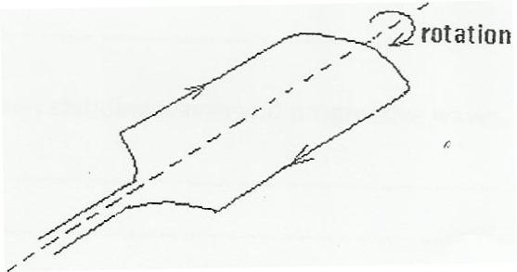

Magnetic field

**1 mk**

**7. **

**1 mk**



**1 mk**



the image is virtual

**8.** t2 - t1 = 0.25

t1 = = 

= 0.588 S

2d /v =0.588+0.2

2d/340 =0.788 s

d=133.96

**9.** a)

|  |  |
| --- | --- |
| Ultraviolet rays | X – rays |
| Microwaves | UV – Rays |
| X-rays | Visible light |
| Visible light | microwaves |

1. i) Ultraviolet rays: detect forgeries, mineral analysis, vitamin D etc

ii) Microwaves: cooking, communication

**10.** P =

**1 mk**

**= **

**1 mk**

**= 9 W**

**11.**

* do not insert foreign objects in sockets
* Do not handle electrical apparatus with wet hands
* Ensure all electrical switches are turned off when not in use

**Section II**

**12**. a) is the plane perpendicular to principal axis that passes through the principal focus

b) i) Shutter: controls the exposure of the film to light

1. Film: captures and records the image
2. Diaphragm: controls the amount of light entering the camera
3. For the first image $\frac{1}{v}=\frac{1}{f}-\frac{1}{u} =\frac{1}{0.8}-\frac{1}{1.2} therefore v=2.4cm$

$$\frac{1}{d-2.4}=\frac{1}{2.5}-\frac{1}{10} d-2.4=3.33 d=5.733$$

* *Two rays from the tip of the object to the tip of the image*
* *Two rays from the bottom of the object to the bottom of the image*
* *image*

**13. (a)***i)* *It* is used to cool the anode by conducting heat away

*ii) Has a* high melting point

(b) I. P = I X V

= 20X 10-3 X 100,000

= 2000W

II. I= nxe

n= I/e

= 20x103/1.6x10-19

= 1,25 x1017

III. eV = KE

=

=J

*( 2 mks)*

1. Energy = 

= 



=5.782eV

**14.**  a) The ratio of the sine of the angle of incidence to the sine of the angle of refraction is constant for given pair of media

b) Due to total internal reflection

1. i) 1**n**3 = 1**n**2 x 2**n**3

2**n**3

2**n**3 =

ii)

**1 mk**

1. Through successive total internal reflection

**1 mk**

**1 mk**

**15.**  a) Charge stored per unit volt.

+ + + + + + + + + + + + + + + -

- - - - - - - - - - - - - - - - - - - - - - - -

b) i)

* Decreasing the distance between the two plates
* Using a dielectric material of higher dielectric constant

ii)

c) i) capacitors arranged in parallel

**1 mk**

$$C_{eff}=C_{1}+C_{2}+C_{3}$$

$=12μF+12μF+12μF$

**1 mk**

$$=36μF$$

ii) Capacitors in series

**1 mk**

$\frac{1}{C_{eff}}=\frac{1}{C_{1}}+\frac{1}{C_{2}}+\frac{1}{C_{3}}$

$= \frac{1}{12}+\frac{1}{12}+\frac{1}{12}$

$= \frac{1}{4}$

**1 mk**

$∴C_{eff}=4μF$

iii) Combining series and parallel

Parallel

C = 12 + 12

**1 mk**

= 24µF

Series

$\frac{1}{C}=\frac{1}{24}+\frac{1}{12}$

$=\frac{1}{8}$

**1 mk**

$∴C=8μ F$

**16.***a)* i

I. r- beta

s- alpha

II. x…83……….

y…82……

ii) I. volatile

II. Lowers the temperature in the chamber until is super saturated

III. Radiation ionizes air inside the chamber

* alcohol droplets form on the air ions produced by the radiation forming white tracks

*iv)* the type of radiation can be detected , i.e can identify the nature of radiation

b)

1. 6 hours
2. *0.1155m*
3. 4 x 106